Summer Course

Week 3 Assignment for Basic JavaScript (Due: September 1st, 2017)

0.Basic Knowledge

You are required to learn the basic usage of JavaScript by yourself. Here are some recommended sourses. You should know :
How to embed JS into the HTML webpage The concept of DOM

How to use JS to modify the HTML and CSS elements, especially how to bind a tag(标签) which has its own class or id.

Imooc: http://www.imooc.com/learn/36

W3school: http://www.w3school.com.cn/js/index.asp (W3school can be used as a manual)

1.Change color

You should make the block drawn in the Week1 Assignment change its color when you move your mouse over it.i.e:
When the mouse is not on the block:
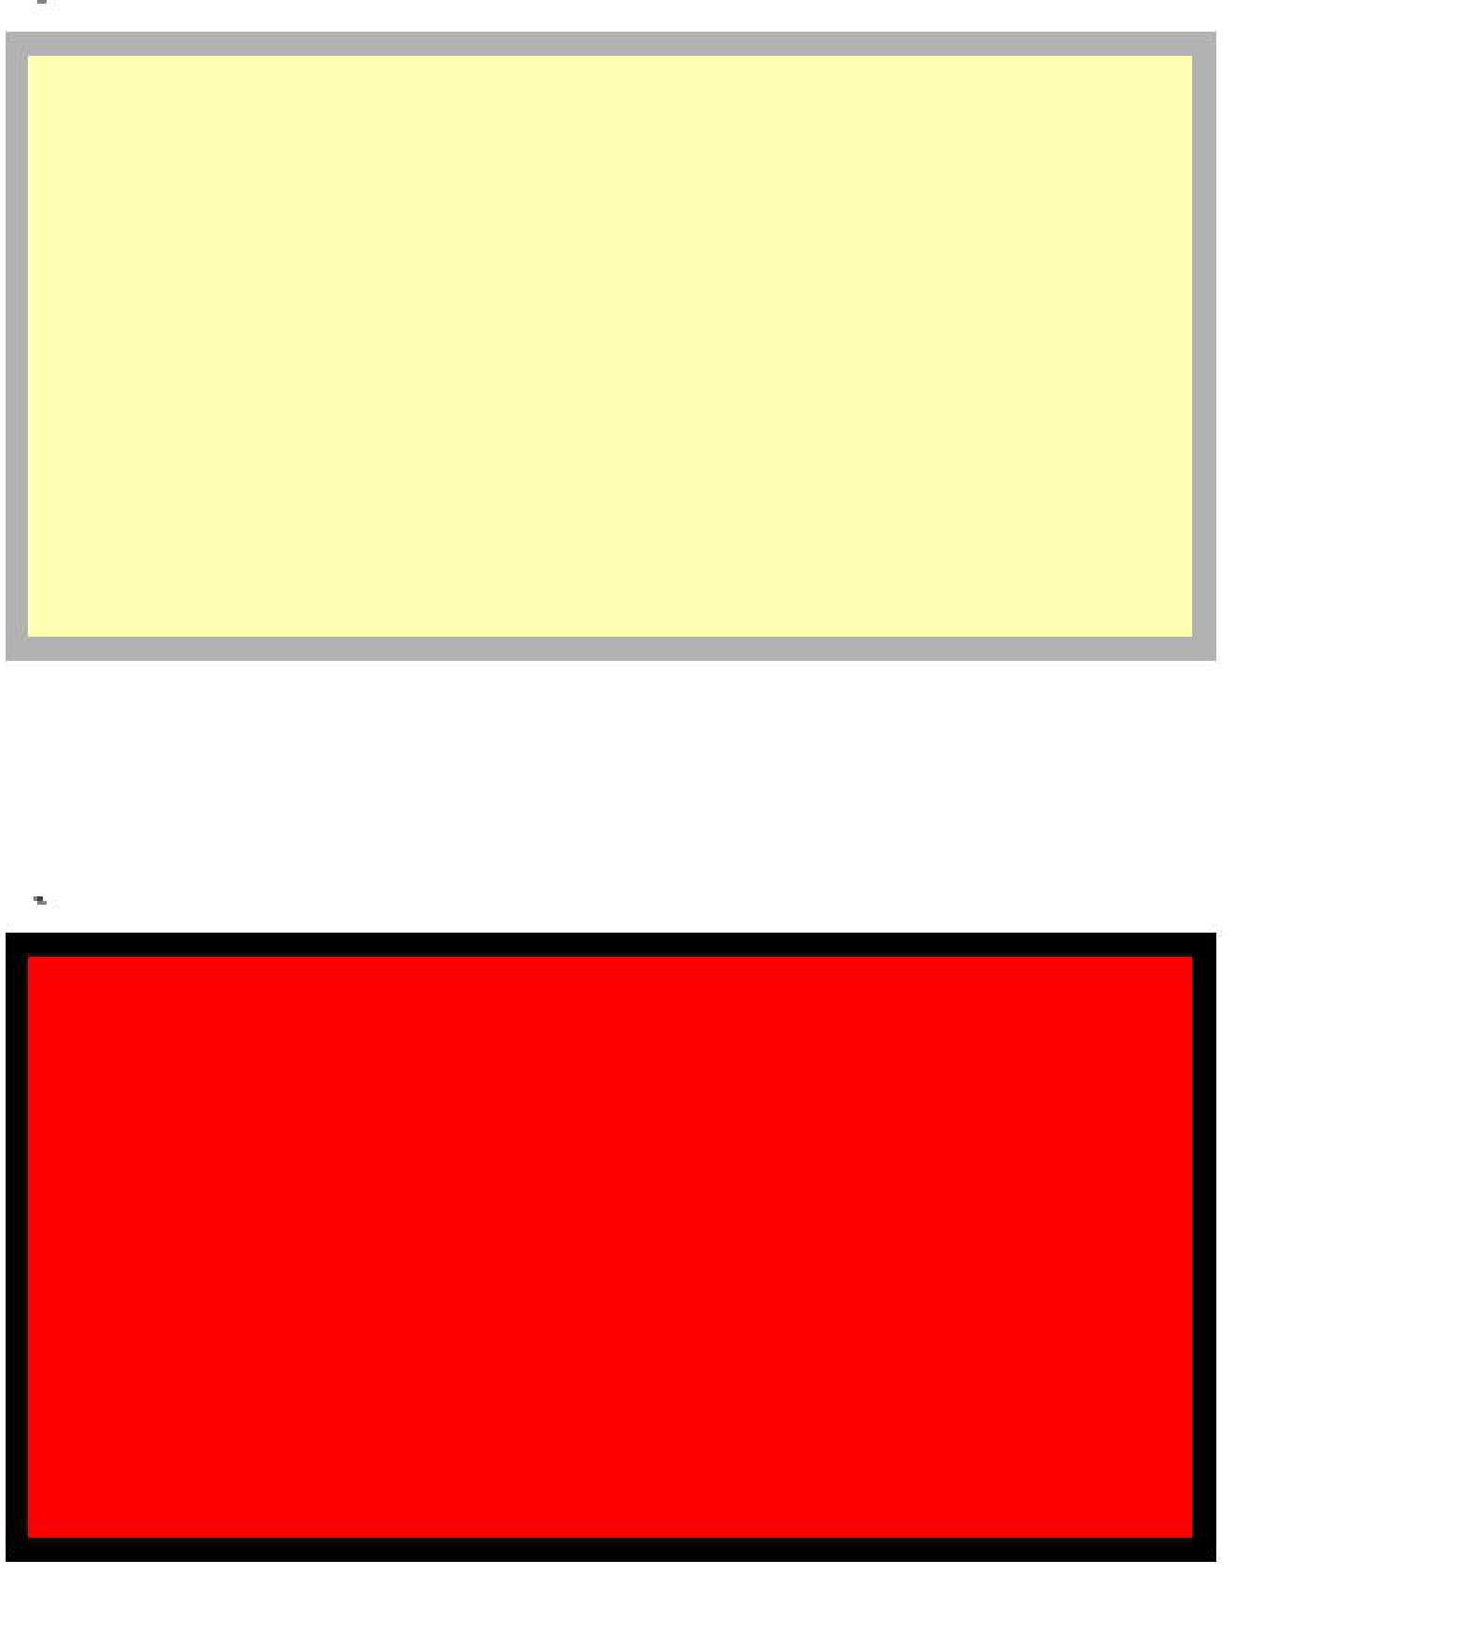

When the mouse is on the block:

When the mouse move out of the block, the color change back to yellow.

Requirement & Hint :

1.The opacity should be 1 when the mouse is on the block. 2.You should contain two or more blocks in this page.

3.You can use function “getElementsByTagName()” to bind multiple blocks. 4.You can use a for-loop to monitor the “onmouseover” event.
e.g : a[i].onmouseover = function(){}

2.Clock

You are required to design a clock which can vary with time. The format of the clock is like the following:



Requirement & Hint:

1.The clock can move simultaneously.

2.You can create a Date type variable and get the current time from your computer. E.g: var myDate = new Date();
Var year = myDate.getFullYear();……

3.You should consider the condition where the second is a number less than 10. In this condition you should add a ‘0’ befor the number of second.
4.You can use the function “setTimeout()” to update the current time. 5.The detail of the function above can be found in w3school.

